# Team Page - Session 4 Take Home

On a lot of websites, you’ll find a Meet the Team page where the company showcases the core team members along with their roles and a short bio or description. You will be given an array of objects and you will need to create cards on the screen dynamically.

The image on the left is the one you start with, the image on the right is the result after adding the script.

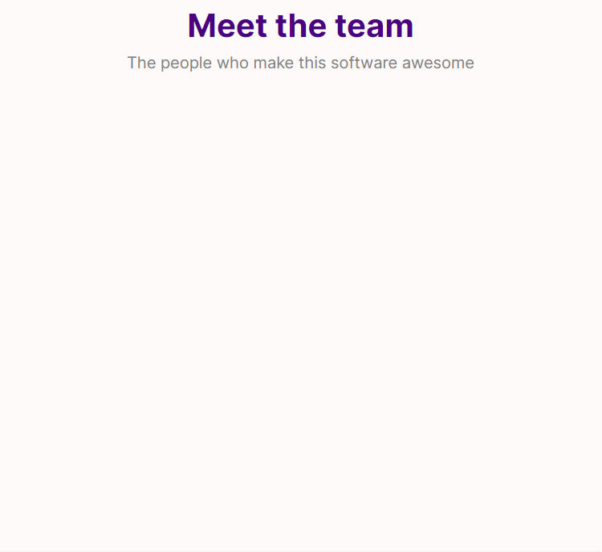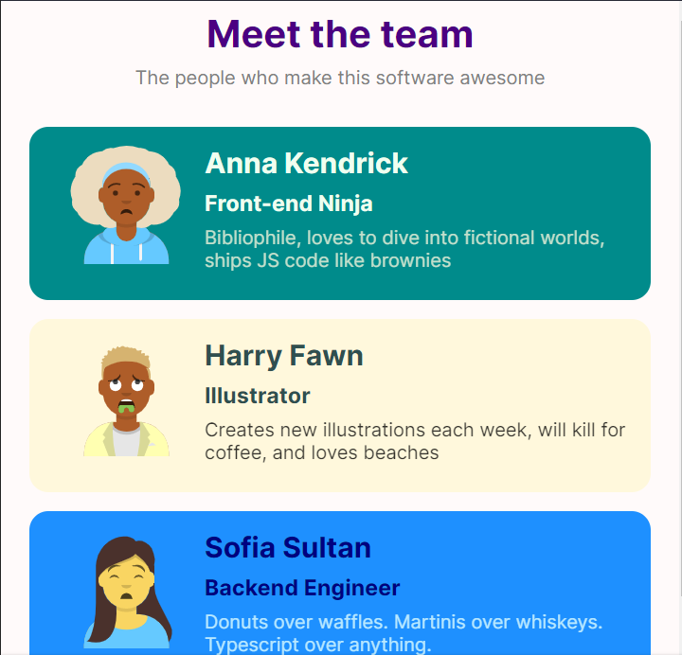

## Getting Started

* Create a new folder, “session4-takehome” inside the sandbox.
* Create 3 new files in this folder - index.html, style.css, index.js
* Follow the link below to get the starter files - index.html, styles.css, and index.js and copy them into the files you just created.

<https://codesandbox.io/s/session-code-fe-2-ge4uq?file=/Session_4/Takehome/index.html>

* Connect the index.js file to the index.html file and start filling in the functions given in the index.js file.
* DO NOT DELETE the team array given in the file, only fill in the functions and the code asked.
* The team array is an array of objects whose properties are referenced below

const team = [

{

id: "anna",

fullName: "Anna Kendrick",

jobTitle: "Front-end Ninja",

bio:

"Bibliophile, loves to dive into fictional worlds, ships JS code like brownies",

avatar: "https://avatars.dicebear.com/api/avataaars/annakendrick.svg"

}

...

];

* The hints to complete the functions are given in the index.js file as comments

## Checklist

* Each object in the team array has 5 properties
  + id - unique for each team array object
  + fullName - Name of the team member
  + jobTitle - Job Title of the team member
  + bio - Bio of the team member
  + avatar - image avatar for the team member
* The section with the id = “content” is selected under which the cards will be added.
* The function generateCard() takes in 5 parameters as described in the index.js file and returns an HTML element
* It uses another helper function called getImageElement(src, alt) which takes in two parameters - *src* which is the image src and the *alt* for the image (you can use the alt as the team member’s name)
  + The getImageElement() function sets the attributes *src*, *alt*, *height*, and *width* for the img element it creates.
  + Set the height and width as 100
  + Return the img element
* Write a generateCardArray(data) function to return an array with card elements generated by the generateCard() function one by one by looping throught the team array.
* Finally loop through this new array generated with the generateCardArray(data) function which takes in the team array as argument and adds the HTML elements to the content.
* The final output for console.log(content) should look like the one given below.

## Final Output

Finally your script should generate the following code

| <section id="content">  <section class="team-member" id="anna">  <img src="https://avatars.dicebear.com/api/avataaars/annakendrick.svg" alt="Anna Kendrick" height="100"  width="100"></img>  <div>  <h2>Anna Kendrick</h2>  <h3>Front-end Ninja</h3>  <p>Bibliophile, loves to dive into fictional worlds, ships JS code like brownies</p>  </div>  </section>  <section class="team-member" id="harry">  <img src="https://avatars.dicebear.com/api/avataaars/harryfn.svg" alt="Harry Fawn" height="100"  width="100"></img>  <div>  <h2>Harry Fawn</h2>  <h3>Illustrator</h3>  <p>Creates new illustrations each week, will kill for coffee, and loves beaches</p>  </div>  </section>  <section class="team-member" id="sofia">  <img src="https://avatars.dicebear.com/api/avataaars/sofiasul.svg" alt="Sofia Sultan" height="100"  width="100"></img>  <div>  <h2>Sofia Sultan</h2>  <h3>Backend Engineer</h3>  <p>Donuts over waffles. Martinis over whiskeys. Typescript over anything.</p>  </div>  </section>  </section> |
| --- |